Main points:

1. I’ve rearranged section 2 and 3 (as discussed), where the original guide introduced the subsections (installing and loading, getting help, interacting with R, objects and saving) in the ‘R’ section but now these are visible in the ‘RStudio section’. I’ve had to move the order of subheadings around just so it all makes sense
2. Not sure how you would like outputs to be displayed, when using the RMarkdown they are produced next to a double hashtag (##) but the guide has screen shots – I’m assuming this might be an issue with comms but for now this draft just using the RMarkdown format. Since the bulk of the code is complete, I’m happy for all further edits to be made on this document
3. Similar to the module, would you prefer to display visualizations using the base package or ggplot? I’ve mainly copied the guide which just uses the base package (but it does seem a little limited)
4. Section 6.1 and 6.2 need some rethinking with the type of variables we have available. Not sure we can run the exact same distributions, but there are others we could introduce
5. Section 6.6; I might advise using the ‘survey package’, it produces easier weighted means without having to introduce ‘plyr’.
6. Section 8 (making maps) – isn’t possible to do with the BSA dataset as we do not have any geographical variables. Either we have to rethink using the BSA dataset or could we use move ‘making maps’ to the further commands in section 9, and include instead a section on logistic regression or one of the other commands?

I’ve tried not change the structure too much but it’s inevitable when using a new dataset with different variables and measures!

Using R/RStudio to Analyse Key Surveys

UKDS

10/09/2021

Table of Contents

1. Introduction 3

1.1 What is R and R Studio 3

1.2 The Pros and Cons of R Studio 4

2. R; essential information 5

3. R Studio 5

3.1 The R Studio Interface 5

3.2 To create a new project and Working Directoy 6

3.3 In order to create a script 6

3.4 Installng and Loading Packages 7

3.5 Getting help 8

3.6 Objects 8

4. Opening UK dataservice in R 10

4.1 Which versions of the UKDS can I use in R 10

4.2 Understand the dataset 11

4.3 Identifying and selecting variables 12

5. Essentials of Data Manipulation 13

5.1. identify and selseting variables and observations 13

5.2 Creating and recoding variables 13

5.3 Renaming categorical variables 14

5.4 Misisng Values 14

6. Descriptive staistics - CONTINUOUS 15

6.1 Distribution graphs 17

6.2 Siginifcance of correlation 19

6.3 Table of summary statistics 19

6.4 Bar charts and plots of summary statistics 20

6.6 Saving and importing a graph in a word document 23

6.6 wighted descriptives 24

visualsing weghted data 25

7. Categorical Variables - contigency tables 27

7.1 One way frequncy table 27

7.4 Creating bar plots of one-way frequency tables 28

7.4 Two way or more continguency table 28

7.4 Test of association between categorical variables 32

7.6 Univariate and bivariate graphs for categorical variables 33

8. Plotting simple maps in R 33

9.1 Further commands and analyses 33

10. Additional online resources 34

11. References 34

## 1. Introduction

The aim of this guide is to provide an introduction to analysing large UK surveys using the statistical software R and its embedded packages. This document is targeted at two categories of users:

1. Those outside higher education, or who do not have access to one of the commonly used statistical packages such as Stata, SPSS or SAS (as R open sourced) but who would like to conduct their own analysis beyond what is usually published by data producers such as the Office for National Statistics (for example statistics for specific groups of the population).
2. More advanced users who are already familiar with one of the aforementioned packages but would like to learn how to carry out their analyses in R. The guide, therefore, focuses on providing step-by-step examples of common operations most users carry out in the course of their research: how to open datasets, do basic data manipulation operations, produce simple descriptive statistics or weighted contingency tables. This is meant to provide the first category of users with a range of procedures that will help them produce straightforward and robust analyses tailored to their needs without spending too much time on learning the inner workings of R. The second category of users will find a number of familiar operations from which they will be able to further expand their R skills. It should be noted however that this guide is not an introduction to R. Beginners should use it in conjunction with one of the more comprehensive guides available online. Links and information about R resources are available at the end of this document.

Examples provided in this guide, use the British Social Attitude Survey (BSA, 2017), which can be downloaded from the UK Data Service website. The website also has instructions on how to acquire and download large-scale government datasets.

### 1.1 What is R and R Studio

R is a free, user developed, advanced statistical and computing program. It has a large audience in the programming and statistical community and is increasingly used in the academic world for teaching purposes. R can be downloaded from the Comprehensive R Archive Network (CRAN) website. Installation instructions as well as guides, tutorials and FAQ are available on the same website.

R is often described as an object-oriented statistical programming language rather than simply a statistical analysis package. It originates in the ‘S’ and ‘S Plus’ languages developed during the 1970s and 1980s. Anyone can download and use it without charge, and to some extent contribute to and amend the existing programs itself. It is particularly favored by users who want to develop their own statistical application or implement the latest advances that are not yet available in commercial packages. The existence of a vast number (more than 3,600 at the time of writing this guide) of user written packages – which bear some resemblance to down-loadable files in Stata – is one of the great strengths of R. Users who want to contribute should be aware that in order to be part of the R archive, a minimum set of rules need to be followed.

Although R can perform most of the tasks available in generalist statistical packages such as Stata, SPSS, or SAS, it has a broader potential since it can also be used for mapping or data mining. Being a language also means that there are often several ways to carry out analyses in R, each one with its pros and cons. Publication quality output from R can be obtained easily thanks to its integration with the LaTeX document presentation system, and R graphs can also be imported into MS Word documents.

### 1.2 The Pros and Cons of R Studio

Although R has advantages over other statistical analysis software, it has also a few downsides, both of which are summarised below. Users should be reminded that as an open-source software, R and its packages are developed by volunteers, which makes it a very flexible and dynamic project, but at the same time reliant on developers’ free time and good will.

|  |  |
| --- | --- |
| Pros | Cons |
| R is free, and allows users to perform almost any analysis they want. | The learning curve may be steep for users who do not have a reasonably robust background in statistics and programming. |
| R puts statistical analysis closer to the reach of individual citizens rather than specialists. | Problem solving (for both advanced and beginners) in R may be time-consuming, depending on how common the problem encountered is and may lead to more time spent solving technical rather than substantive issues. |
| Transparency of use and programming of the software and its routines, which improves the peer-reviewing and quality control of the software in many cases | Packages can stop being maintained without notice, and some of them have a short life span. Many people who design them are or will become busy academics, and at some point will not have the time to maintain them anymore. Others will take over in some, but not necessary in all the cases |
| Very flexible |  |
| Availability of a wide range of advanced techniques not provided in mainstream statistical software or only available in specialised packages |  |
| A very large user base provides abundant documentation, tutorials, and web pages |  |

## 

## 2. R; essential information

The R installation programs can be downloaded from the CRAN website and run like any other Windows applications. Versions for Mac and Linux are also available.

Not sure if you want to include this section/add more to this section, maybe specific steps about installing, or toinclude more information about the differences between R and RStudio?

## 3. R Studio

There is a more user-friendly way of using R that is becoming increasingly popular among R users, which is R Studio. This software package is available to download from this website: <https://www.rstudio.com/>.

In R Studio, R syntax works exactly the same as with the traditional R environment, but the interface is more interactive, which makes it easier to use.

### 3.1 The R Studio Interface

Once you open R studio you will be directed to a screen with three main panels;

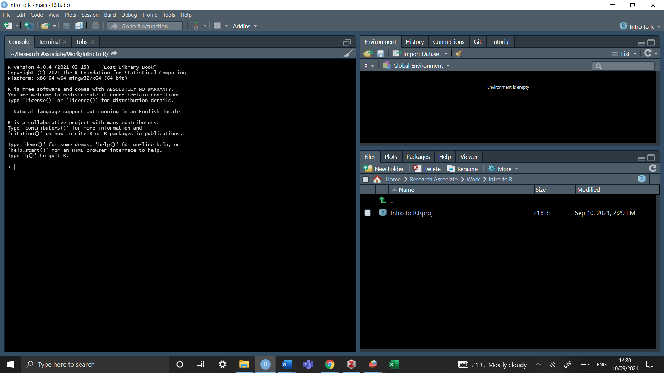

What we are working is an ’empty interface. RStudio project is just a directory (a folder) with the name of the project, and a few files and folders created by R Studio for internal purposes.

Tip:

If you want to change the aesthetics as seen above simply go to *tools* -> *global option* -> *appearance* and choose your desired aesthetic

### 3.2 To create a New Project and Working Directoy

Go to *File* -> *New Project* -> *New Directory* -> *New Project*

And then select a name and folder in which you want to save this. Now you have what is known as a working directory - any additional data should be saved into this folder (but we’ll cover this later)

If you don’t want to create a project, maybe because you’re working with smaller data you can simply set and check you working directory via

getwd() #identifies which folder R uses by default to store and retrieve files   
  
setwd("C:Documents/username/mydocuents/BSA") #set your working directory by choosing your desired location on your computer (the folder BSA would need to be created first)

Additionally, you set this manually though the graphical interface via

*file* -> *change directory*

Some notes:

• any character string that is neither a command nor the name of an object (such as a variable name) needs to be put between inverted commas or quotation marks - see the example below about loading user-created packages. • even when no parameters are specified for a command, brackets are compulsory as shown in the getwd () example above • R uses forward slashes (/) rather than backslashes (unlike most Windows applications) to separate directories. Using backlashes will return an error message • although in theory most R commands require a large number of options to be specified, in many cases default values have been ‘factory set’ so that only the essential parameters need specifying.

### 3.3 In order to create a script

There are three methods to creare a new script;

* *File* -> *New File* -> *New script*
* Press the ‘Plus’ green button
* Cltr + Shift + N

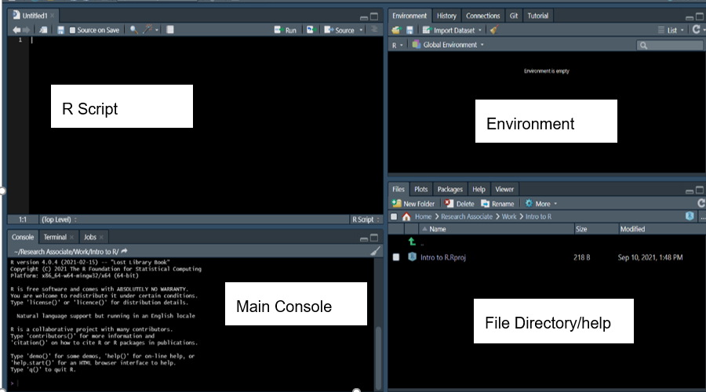

Now you will see four panels

* 1. the script is where you code is written
  2. The main console produces the results from the script.
  3. The environment saves any dataframes or objects that are being used
  4. The file directory is where all packages are saved under CRAN, there is also a help menu

Practice talking to your computer; in the scrip type “My name is (your name), run the code by pressing CTRL+R (or at the top of the panel click” Run") and you will see this code in your main console - this is how R communicates!

print("My name is x")

## [1] "My name is x"

### 

### 3.4 Installing and Loading Packages

Apart from a basic set of commands and functions, most of the tools offered by R are available in packages that are not provided during the main installation and need to be installed and downloaded separately from within R. For example, in order to install the foreign package which allows users to import Stata or SPSS datasets, one needs to type:

The following code downloads packages into R

install.packages("forigen")

In order to use packages they have to be LOADED via the library function

library(foreign)

Every time you restart up R you will have to load packages again but once a package is installed it will be perminately stay in your file directory, unless deleted using this command

remove.packages("foreign")

### 3.5 Getting help

The standard help system in R (unless otherwise chosen at the time of installation) relies on the default web browser (Firefox or Internet Explorer in most cases) to display pages. Within R, the most straightforward way to request help with a command consists of a question mark followed by the command name, without a space in between.

Typing *?getwd* is the equivalent of *help(‘getwd’)* and will open the help page for the getwd() command in the default web browser.

?getwd  
  
help('getwd')

This will work for any command directly available in memory (ie in the default package or those in the packages loaded via the library()) command. Otherwise, R will return an error message.

Typing two question marks followed by a keyword will search all of R the available documentation for that keyword

??foreign

An index of all commands and functions in the foreign package can be obtained by typing:

help(package='foreign')

This only work because the ‘foreign’ package was previously loaded in memory with the library() command.

More information about where to find help when using R is provided at the end of this document.

### 3.6 Objects

An object is a dataframe that can be created and will exist in your global environment. To create an object you use the assignemnt operator which is just an arrow (<-). For example

x <- 5

In this example we’ve assigned the value 5 to an object call x - can you see it in your environment to the right. Run just ‘x’ and you will the value appear in your console

x  
  
## [1] 5

#### Deleting objects in R

To delte an object use rm() function

rm(x)

Now its removed from your global environment!

#### Saving objects and more in R

When working with data, it is very likely that the user will edit the original dataset, either by recoding variables or creating new ones, etc. In those cases, saving the progress made in the data used is crucial to avoid repeating every single operation in the next session working with the data. There are several ways of accomplish this, depending on the format in which the data will be stored. The line of command used to save the data frame used called “mydata” is:

save(mydata, file="mydata.Rda")

This command will save the data into a format that can be read by R. The first part of the command is referring to the data frame used in the current R session, while the section file=“mydata.Rda”, is referring to the data that will be saved in the working directory. The name of the saved file can be changed, for instance:

save(mydata, file="mydata_Jan17.Rda")

To load the saved .Rda data:

load("mydata_Jan17.Rda")

This command will work only if the working directory where the data is stored is defined in advance (see section 2). Alternatively, the path to the folder where the data is saved can be specified.

load("c:/mydocuments/mydata_Jan17.Rda")

Another option to save the data is using the “foreign” package, so data can be exported to several formats, such as .txt, .cvs, .dta, which can be used in other software packages. The following example shows how to export data from R to a comma delimited format (.csv) that can be read in excel, Stata and SPSS.

library(foreign)  
write.csv(mydata, “mydata.csv”, row.names=FALSE)

Another example is to export the data as a Stata file, using the foreign package previously loaded:

write.dta(mydata, "mydata.dta")

The newly created files will be stored in the working directory defined earlier on.

Some users will want to save the whole R project in which they are working. This would include functions, variables, data (in R it is possible to load and work with more than one dataset at a time). This option comes very handy, especially when working with several datasets.

Thus, another approach is to save the current session or workspace as an image, using the save.image command, specifying the path where the workspace will be saved. For example, to save ‘my current session’ in R, one needs to write the following command, making sure to include the .RData extension.

save.image("c:/Folder/my_current_session.RData")

This will open a window to save the workspace in a particular folder, which can be different from the current working directory. The name needs to be specified in the ‘File name’ section. The workspace will be saved in the chosen folder as an .RData file.

The data can be retrieved using the load function

load("c:/Folder/my_current_session.RData")

Or using graphical interface as follows:

*File* -> *load workspace*

## 4. Opening UK dataservice in R

In this guide, we use the British Social Survey 2017 survey, which can be downloaded from the UK Data Service website. The website also has instructions on how to acquire and download large-scale government datasets.

Once downloaded, save this into the same project folder we created earlier.

### 4.1 Which versions of the UKDS can I use in R

Pay attention to what type of file you have downloaded (whether csv, spss or stata) as this will affect how you import data into R

If you have saved the download file into the same project folder you won’t have to specify the full path line

bsa <- read.dta("bsa.dta") #dataframe   
bsa <- read.spss("bsa.sav", to.data.frame = TRUE) #spss file   
bas <- read.csv(("bsa.csv")) #cvs file

In R jargon, we have loaded the content of the LFS file into an R object which is called a ‘data frame’. By contrast with Stata and SPSS, R allows users to open several datasets simultaneously, so we could for example load another issue of the BSA into the memory.

The number of datasets that may be opened simultaneously is only limited by the computer’s physical memory. R uses by default all the memory available on your computer if necessary. This means however that the programme can become slow if you open a very large dataset on a computer

Note: The foreign package can only read Stata files up to version 12 . To import data from Stata version 13 and above, the data need to be saved in Stata 12 version. The Stata command saveold is useful for this.

To save the file ‘example_v13.dta’ (already loaded in Stata) in Stata 12 version, use the following command:

saveold example_v13, version(12)

The data will be saved in a version compatible with the ‘foreign’ package of R, so it can be imported into R using the ‘read.dta’ function.

There are other alternatives to import data from Stata (up to version 14), SAS and SPSS. This is the newly created package called ‘haven’ by Hadley Wickham and Evan Miller.

### 4.2 Overview of the dataset

The view function returns the whole dataset;

View(bsa)

Notice the capital ‘V’ – RStudio is case sensitive so packages, datasets and variable have to be written correctly or you may receive an error message

How many observations and variables are there in the dataset?

dim(bsa)

*[1] 3988 25*

There are 3988 observations and 29 variables

How do you explore one variable?

bsa$Rsex

This produces the first 100 observations which can be messy to read. The summary functions summarises the type of variable and how mnay observations there are.

summary(bsa$Rsex)

Now we can see that there are 1806 Males and 2182 Females in ourdatset

In order to vie the first 6 rows of the dataset, the ‘head’ function can be used

head(bsa)

Since an R session may involve several datasets at the same time, having variable names immediately recognized when typed requires that we ‘attach’ a dataset as the default data frame.

attach(bsa)

We can now omit the lfs$ prefix when specifying a variable in our analyses.

Despite the practicalities of the attach/detach command, it is always advised to use this code with caution, since the risk of confusion is greater, especially when working with several datasets at a time and when the same variable names are used in different datasets. Many online references can be found advising about whether to use or not the attach function. For instance, on the UCLA website , there is a brief explanation of the main issues.

*This guide will not be using this package* - this is actually up to you Sarah, here’s an example how different the output can look with and without the package

#using attach

bsa$Married[6]

## [1] Never married  
## 4 Levels: Married/living as married Separated/divorced ... Never married

#the output will look like this;  
  
#[1] Never married  
#4 Levels: Married/living as married Separated/divorced ... Never married  
  
#You'd also have to know the column number of each variable (6), with this example as well the variable names are quite long so they don't appear correctly

#not using attach

levels(bsa$Married)

## [1] "Married/living as married" "Separated/divorced"   
## [3] "Widowed" "Never married"

#output without  
  
#[1] "Married/living as married" "Separated/divorced"   
#[3] "Widowed" "Never married"

### 

### 4.3 variable types

As we have already seen, variables are objects. R automatically stores variables using the appropriate object class. Categorical variables are ‘Factors’ with ‘Levels’ as categories within these, while continuous variables are ‘Numeric’ types of object.

If one is unsure about which class an object belongs to, one can use the class() command in order to find out by tpying *class(dataset$variable)*

class(bsa$Rsex)

## [1] "factor"

The variable Rsex is marked as a ‘factor’ which translates to mean a categorical variable. To see what levels are within the variable we can use ’levels()

levels(bsa$Rsex)

## [1] "Male" "Female"

#[1] "Male" "Female"

What about a continuous variable?

The variable ‘leftright’ is marked as a ‘factor’ which is strange because this is actually a numeric variable ranking people’s political opinion on a scale from left to right

class(bsa$leftrigh)

## [1] "factor"

#[1] "factor"

So why has R is telling us this is a factor - well this is the issues with R, it doesn’t understand the metadata and how these variables were collected for the survey - it’s always important to check you levels of measurement with your datasets!

We will show you how to recode this variable into a ‘numeric’ in the next seciton!

## 5. Essentials of Data Manipulation

Before attempting to produce statistical analyses in R we need to learn how to recode variables and deal with missing data.

### 5.1. identify and selseting variables

Data frames consist of rows and columns, in the same way as Stata or SPSS datasets. Each row and column can be identified by its number between square brackets: data.frame[row,colums]

bsa[6, 4]

## [1] Never married  
## 4 Levels: Married/living as married Separated/divorced ... Never married

# [1] Never married  
# Levels: Married/living as married Separated/divorced Widowed Never married

we will get the value of the 8th observation (row) of the 4th column in the data. Which happens to be the variable ‘Married’ - in this instance this surveyor has never been married.

To get a summary of a variable use;

summary(bsa$Married)

On a categorical variable this will return the levels (same as the levels() function). For a continuous variable this will return mean, median and interquartile ranges

### 5.2 Creating and recoding variables

bsa$leftrigh_log <- log(bsa$leftrigh)

Oh you recieve an error *Error in Math.factor(bsa$leftrigh) : ‘log’ not meaningful for factors* - Not to fear, R doesn’t always know what variables you have and what they mean. As mentioned,. the variable *leftrigh* is a numeric variable measuring someone’s score on the left-right political scale. In survey data it is always important to check the metadata of your dataset which will tell you what type of variabls you have.

we can simply covert this into a numeric variable and then run the code again

bsa$leftrigh <- as.numeric(bsa$leftrigh) #covert to numeric   
class(bsa$leftrigh) #check to see if it is numeric  
  
bsa$leftrigh_log <- log(bsa$leftrigh) #create new log of the leftright variable

### 5.3 Renaming categorical variables

In the case of categorical variables, we need to keep in mind that the possible values of the variables are what the summary() or the levels() commands returned – i.e. actual names: there are not numeric values to which value labels are added as with other programmes:

In the variable ‘Married’ which identifies someones status of marriage

levels(bsa$Married)

## [1] "Married/living as married" "Separated/divorced"   
## [3] "Widowed" "Never married"

#[1] Married/living as married Separated/divorced   
#[3] Widowed Never married

We can create a new variable that recodes ‘seperated/divorced’(2) and ‘Never married’ (4) into a new variable called ‘Not Married’

Its always advised to create new variables when recoding old ones so original data is not tamperd with, we have named this ‘Married2’

bsa$Married2 <- bsa$Married #Create a new variable that copies the original level   
levels(bsa$Married2) #check the levels are the same

## [1] "Married/living as married" "Separated/divorced"   
## [3] "Widowed" "Never married"

levels(bsa$Married2) <- c("Married/living as married", "Not Married", "Widowed", "Not Married")   
  
levels(bsa$Married2)

## [1] "Married/living as married" "Not Married"   
## [3] "Widowed"

So, the second and fourth variables have been renamed to ‘Not Married’ as this is where their original levels were in the sequence

### 5.4 Misisng Values

Important: From now on, we will ‘detach’ the lfs file, so all the data manipulation will be stored in the actual data frame.

We first create a copy of the lfs data, so we will keep an intact copy of the original dataset. If you check the ‘Environment’ section of your R Studio screen, you will see two datasets loaded: lfs and lfs_copy

bsa_copy <- bsa

In R, missing values are presented as NA.

Handling missing values in R is a bit more complex that in other packages as by default there are fewer safety nets than in other packages, for instance to tell users how many observations with missing values have been dropped in a variable. In addition, some commands can return error messages when dealing with variables whose missing values have been recoded to NA since they won’t necessarily have the same number of ‘rows’.

#### 5.4.1 check for total of NAs

To check sums across a specific variable or a whole dataset use ***sum(is.na(dataset$variable))***

sum(is.na(bsa_copy)) #in the whole dataset  
#[1] 35763  
  
sum(is.na(bsa_copy$leftrigh)) #in the leftright variable   
#[1] 782   
  
mean(is.na(bsa_copy$leftrigh)) #returns the proportion of NAs  
  
is.na(bsa_copy$leftrigh) #returns true or false values

#### 

#### 5.4.2 Recoding missing values as NA (continous)

dataset$new_variable <- dataset$old_variable #duplicate variable   
dataset$new_varaible[dataset$old_variable < 0] <- NA #convert all 0s to NA

#### 

#### 5.4.3 Recoding missing values as NA (categorical)

If you had responses such as ‘does not apply’ or ‘no answer’ you can rocode them to represet NA

dataset$new_variable <- dataset$old_variable   
dataset$new_variable[dataset$new_variable == "Does not apply" |  
 dataset$new_variable == "No Answer"] <- NA

#### 

#### 5.4.4 Deleting NAs

Would you like a section on deleting NAs ?

## 

## 6. Descriptive staistics - CONTINUOUS

In this section, we will review a few typical analyses that beginners may be interested in: producing uni- and bivariate statistics with either continuous or categorical variables.

Producing descriptive statistics in R is easy, some of the functions come ready to use without any additional package needed. We have already seen above that the summary() command provides essential information about a variable. For instance,

summary(bsa$leftrigh, na.rm = T)

## Min. 1st Qu. Median Mean 3rd Qu. Max. NA's

1.00 9.00 12.00 12.53 16.00 30.00 782

will give information about the mean, median and quartiles of the hourly earnings of respondents.

The describe() command in the Hmisc package provides a more detailed set of summary statistics. We need to install and load Hmisc first

install.packages("Hmisc")  
library(Hmisc)

Then

describe(bsa$leftrigh)

describe() also gives the number of observation (including missing and unique observations), deciles as well as the four largest and smallest values. In addition to this, commands producing specific statistics are also available:

In addition to this, commands producing specific statistics are also available:

mean(bsa$leftrigh, na.rm = T)

## [1] 12.52838

The added na.rm = T (or na.rm = TRUE) option prevents missing values from being taken into account (in which case the output would have been NA). Other similar commands that compute individual statistics are available by default , such as sd(), max(), min().

Using these individual commands may come in handy, for instance when further processing of the result is needed:

m <- mean(bsa$leftrigh, na.rm= T)  
rm <- round(m,2)  
rm  
  
## can be created in one line like so   
  
round(mean(bsa$leftrigh,na.rm=T),2)

## [1] 12.53

### 

### 6.1 Distribution graphs

We can use the ‘hist’ function which is part of R’s base package to run a histogram of the political scale. The histogram will be visible in the ‘Plot’ tab in the lower right side of the R Studio window. You can see it in another screen by clicking on ‘zoom’. There are other options available for the plots; you are free to explore them on your own.

hist(bsa$leftrigh)

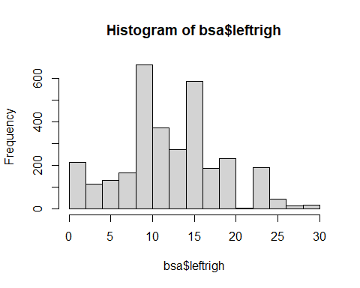

Custom titles, notes and legends as well as colours, can be added to a R plot. See ?hist for more details.

Instead of a histogram, we can also produce a box and whisker plot of the same variable:

boxplot(bsa$leftrigh)

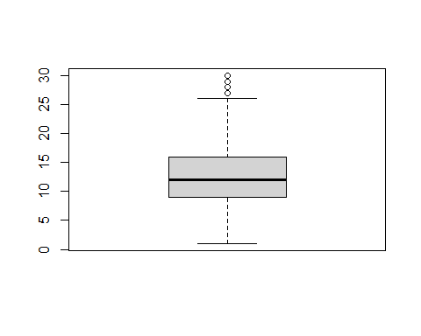

The rest of this section can’t really be replicated to the BSA datset, due to the differences in levels of measurements

### 6.2 Siginifcance of correlation

//

### 6.3 Table of summary statistics

We may want to go a bit further and produce a table of summary statistics, that is to inspect the distribution of a variable for (a) given subpopulation(s) or across the categories of another variable, for which we will need the command summaryBy() in the package doBy. Remember to install the package first.

library(doBy)

## Warning: package 'doBy' was built under R version 4.0.5

summaryBy(leftrigh ~ Married2, data = bsa, FUN = mean, na.rm = TRUE)

## Married2 leftrigh.mean  
## 1 Married/living as married 12.95304  
## 2 Not Married 11.76247  
## 3 Widowed 12.82877  
## 4 <NA> 1.00000

Notes:

The first parameter which specifies the continuous and categorical variable delimited by a tilde (~) is called a ‘formula’ in R jargon and is used by several other commands (such as contingency tables or regression analysis).

* In the case of summaryBy(), the second term of the formula is always the categorical variable, and there can be more than one specified, in which case the mean will be computed for each combined categories of the variables to the right of the tilde.
* The ‘FUN’ term can consist of several statistics, in which case they must be combined using the c() command.
* The source of the data needs to be mentioned explicitly whether or not a data frame has been previously attached as the default one.

summaryBy(leftrigh ~ Married2 + Rsex, data = bsa, FUN = mean, na.rm = TRUE)

### 6.4 Bar charts and plots of summary statistics

As with any other R command, we can store the output of summaryBy() into an object. In this case, the default class is a data frame, with the same properties as the ones described above. The advantage of having results stored in a data frame is that it can be easily used with one of R graphical commands. These graphs can be saved as files which can in turn be imported in Word documents.

Let us begin with a simplified version of the summary table shown above and store it in a data frame called g:

g <- summaryBy(leftrigh ~ Married2, data = bsa, FUN = mean, na.rm = TRUE)

There are several plots commands that we can use to plot these data: barplot() is the most common and works out of the box with simple plots (for instance if we only had one categorical variable in the data):

barplot(g$leftrigh.mean, names.arg = g$Married2)

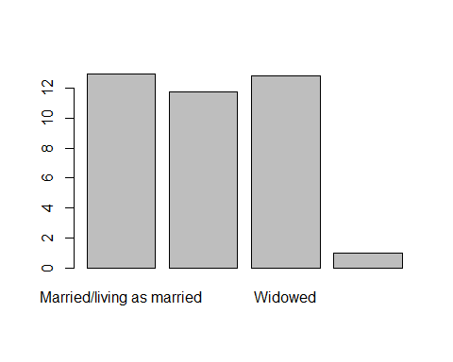

The first parameter specified the variable to be plotted, the second one the labels or categories for each one of the means that are plotted. In both case, the data frame to which the values belong needs to be specified. This initial plot is not fully satisfactory: the names of the regions are not displayed properly. Using a horizontal bar plot and adjusting the margins of the window would give a better result:

barplot(g$leftrigh.mean, names.arg = g$Married2, col = 'blue', las =1)

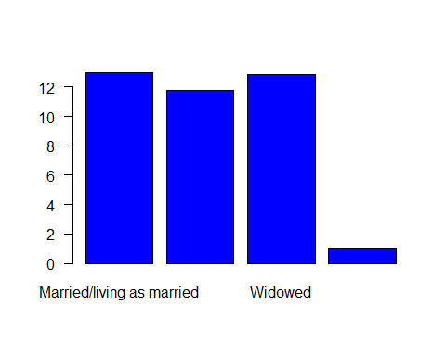

This graph still looks a bit rudimentary. The ggplot() command in the ggplot2 library will give a better output of publication quality. It is however more complex to use.

First, let us go back to our initial two way table of political scale by gender and mairrage status:

library(ggplot2)  
  
g2 <-summaryBy(leftrigh ~ Married2 + Rsex, data = bsa, FUN = mean, na.rm = TRUE)

ggplot(g2, aes(GOVTOF2, HOURPAY.mean, fill=SEX)) + geom_bar(stat=‘identity’, position = ‘dodge’) + coord_flip() +

ggplot(g2, aes(Married2, leftrigh.mean, fill=Rsex)) +   
geom_bar(stat='identity', position = 'dodge') +   
coord_flip() + xlab('Marriage Status') +   
ylab('Mean Political Scale')

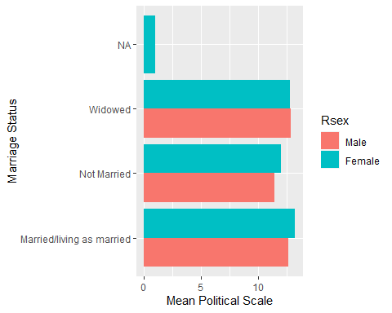

Note: Unlike Stata, R does not assume that commands end with lines. It will continue reading the script file until it finds the characters that are supposed to complete it: in many cases, the closing bracket ‘)’.

Unfortunately, the syntax of ggplot2 does not fully respect the convention of most other R commands. Each parameter is specified by adding a ’+’, followed by the parameter name and its own options between brackets:

The first parameter is the name of the data frame from which the graph is to be drawn;

* aes() or aesthetic specifies the first two variables to be plotted as ‘x’ and ‘y’, whereas the third one is specified as ‘fill’ variable;
* geom_bar() specifies the appearance of the bars, for example whether stacked or not. Stacked is the default option; here we used ‘dodge’, which allows putting the categories of the ‘fill’ variable side by side;
* coord_flip() specifies the orientation of the graph (ie horizontal )
* xlab and ylab are the title of the x and y axis, respectively

ggplot offers many possibilities and it is recommended that users interested should consult the documentation on its website.

### 6.6 Saving and importing a graph in a word document

Any R graph can be saved as an image file that can be subsequently imported in a Word or Latex document, for example. In this example, we will create a PNG image with the graph we have just created using the ‘ggsave’ option. By default, ggsave saves the last plot created, so we can simply write the following command, specifying the name of the plot (g2) and the format in which we want the graph. In this case, we will select ‘png’, but it can be other formats, such as: ‘.pdf’, ‘.jpg’, etc.:

ggsave("g2.png")  
ggsave("g2.pdf")

We can also store the plot in R and then save the specific plot that we need. This is useful when we have several plots and we want some of them in a format that can be exported. With ggsave we can also specify the dimensions of our graph and the units of preference.

Here we save the plot in our R console under the name of ‘g2plot’

g2_plot <- ggplot(g2, aes(Married2, leftrigh.mean, fill=Rsex)) +   
geom_bar(stat='identity', position = 'dodge') +   
coord_flip() + xlab('Marriage Status') +   
ylab('Mean Political Scale')

Now we are saving (exporting) the plot into our working directory. The first argument, ‘g2plot.png’ corresponds to the name and format we are giving to our plot, the second argument is referring to the stored plot (in the R environment) that we want to save, and the others arguments indicate the dimensions and units of our png file.

ggsave(‘g2plot.png’, g2plot,   
 width = 15, height = 20, units = "cm")

A more general approach to save any type of plot (without using ggsave) is the following, where the first line of command creates the file, the second one ‘fills’ it with a graph, and the third one, closes it.

png('g2plot2.png')  
  
ggplot(g2, aes(Married2, leftrigh.mean, fill=Rsex)) +   
geom_bar(stat='identity', position = 'dodge') +   
coord_flip() + xlab('Marriage Status') +   
ylab('Mean Political Scale')

### 

### 6.6 weighted descriptive

The dataset used in this module consists of an individual-level weight named ,‘WtFactor’ which takes into consideration the unequal selection probabilities and non-response of the survey.

To link the bsa dataset to the weights;

library(survey)

## Loading required package: grid

## Loading required package: Matrix

##   
## Attaching package: 'survey'

## The following object is masked from 'package:Hmisc':  
##   
## deff

## The following object is masked from 'package:graphics':  
##   
## dotchart

weighted_data <- svydesign(data = bsa,   
 id = ~1,   
 nest = TRUE,   
 weights = bsa$WtFactor)

The basic functions from the survey package

svytable(~Married, weighted_data) # for weighted frequency table (categorical)  
  
svytable(~Married + Politics, weighted_data) # for weighted contingency tables (categorical)  
  
svymean(~leftrigh, weighted_data, na.rm=TRUE) # for weighted mean and Standard error (continous)  
  
svyquantile(~leftrigh, weighted_data, quantile=c(0.25, 0.5, 0.75), ci=TRUE, na.rm=TRUE) # for weighted quantile (continous)

to calculate weighted proportions simply add prop.table before

prop.table(svytable(~ Married + Politics, weighted_data),1) #row %  
prop.table(svytable(~ Married + Politics, weighted_data),2) #column %

to obtain the percentages

round(prop.table(svytable(~ Married + Politics, weighted_data),1),3) #row %  
round(prop.table(svytable(~ Married + Politics, weighted_data),2),3) #column%

The first number indicates the row or column percentage, and the second number indicates what decile place you ar rounding to

### 

### visualsing weghted data

we can use the base package in R to make historgrams and boxplots:

svyhist(~leftrigh,   
 weighted_data,   
 main="left/right political scale - weighted data",   
 freq = TRUE,  
 col="lightblue",  
 breaks = 30)

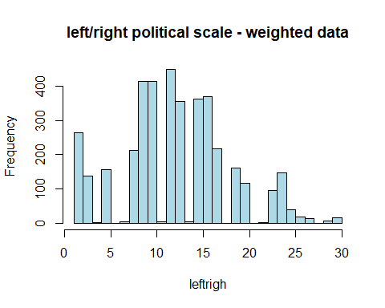

svyboxplot(leftrigh ~1,   
 weighted_data,   
 main="left/right political scale - weighted data",   
 freq = TRUE,  
 col="lightblue",  
 breaks = 30)

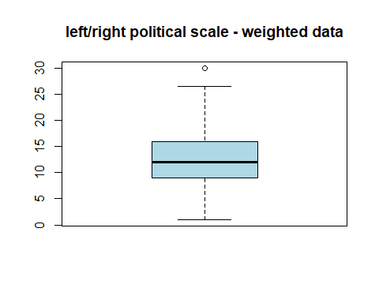

## 7. Categorical Variables - contigency tables

As with continuous variables, R offers several tools that can be used to create contingency tables assess their statistical significance and graph the results.

### 7.1 One way frequncy table

The simplest R command that we can use is table() which returns the number of observations within each level of a factor:

a <- table(bsa_copy$Politics)  
a

##   
## ... a great deal, quite a lot, some, not very much,   
## 739 982 1179 708   
## or, none at all?   
## 379

By itself, table() does not compute proportions nor percentages. These have to be specified manually using prop.table(). The following computes the percentages for the above table out of the raw proportions given by prop.table(). We also round the results to three decimal digits which actually means one digit once the proportions have been converted to percentages:

round(prop.table(a),3)*100

##   
## ... a great deal, quite a lot, some, not very much,   
## 18.5 24.6 29.6 17.8   
## or, none at all?   
## 9.5

### 

### 7.4 Creating bar plots of one-way frequency tables

The barplot() function described above is also suited to draw simple graphs of frequency tables. Going back to the previous command, we can type:

g3 <-round(prop.table(a),3)*100  
par(mar=c(4,8,2,2))  
barplot(g3,horiz=T, xlim=c(0,50), las=1)

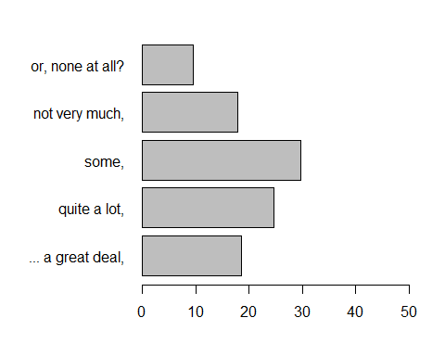

As above, we use par(), to adapt the size of the graph window to the length of category names of the ilodefr variable. The option ‘mar’ stands for margin size and represents a numeric vector of length 4, which sets the margin sizes in the following order: bottom, left, top, and right.

As with any plot() type of command, the colour of the bars, their orientation as well as titles can be easily specified – users can type ?barplot for more information.

### 7.4 Two way or more contingency table

table(bsa$Politics, bsa$Rsex)

##   
## Male Female  
## ... a great deal, 437 302  
## quite a lot, 487 495  
## some, 497 682  
## not very much, 245 463  
## or, none at all? 139 240

If three or more variables are involved, then we will need to use another command. xtabs(), also available by default in R which allows for three way contingency tables. In order to examine political differnces in marriage status and sex

xtabs() which follows a syntax that is similar to summaryBy()since the variables in the table are specified using a formula:

xtabs(~bsa$Married2 +  
 bsa$PartyId2 +  
 bsa$Rsex,   
 drop.unused.levels = T)

## , , bsa$Rsex = Male  
##   
## bsa$PartyId2  
## bsa$Married2 Conservative Labour Liberal Democrat Other party  
## Married/living as married 409 379 74 56  
## Not Married 166 234 41 37  
## Widowed 52 31 9 4  
## bsa$PartyId2  
## bsa$Married2 None Green Party  
## Married/living as married 111 20  
## Not Married 84 11  
## Widowed 4 0  
##   
## , , bsa$Rsex = Female  
##   
## bsa$PartyId2  
## bsa$Married2 Conservative Labour Liberal Democrat Other party  
## Married/living as married 350 408 58 45  
## Not Married 170 331 39 42  
## Widowed 116 95 20 9  
## bsa$PartyId2  
## bsa$Married2 None Green Party  
## Married/living as married 142 21  
## Not Married 147 24  
## Widowed 27 3

Note: The output of table() and xtabs() can be stored into object of the ‘table’ class.

b <- xtabs(~bsa$Married2 +  
 bsa$PartyId2 +  
 bsa$Rsex,   
 drop.unused.levels = T)

The crosstab() command in the package ‘descr’ allows us to directly obtain a two-way contingency table with row and/or column percentages

#install.packages('descr')  
library(descr)

## Warning: package 'descr' was built under R version 4.0.5

##   
## Attaching package: 'descr'

## The following object is masked from 'package:janitor':  
##   
## crosstab

crosstab(bsa$Rsex, bsa$PartyId2, #our two categorical varaibles   
 prop.r=T, #show row % (for column, prop.c =T)  
 plot=F, #plot   
 digits=1) #rounding

## Cell Contents   
## |-------------------------|  
## | Count |   
## | Row Percent |   
## |-------------------------|  
##   
## ==============================================================================  
## bsa$PartyId2  
## bsa$Rsex Consrvtv Labour Lbrl Dmc Othr prt None Grn Prty Total  
## ------------------------------------------------------------------------------  
## Male 627 644 124 97 199 31 1722   
## 36.4% 37.4% 7.2% 5.6% 11.6% 1.8% 45.7%  
## ------------------------------------------------------------------------------  
## Female 636 835 117 96 316 48 2048   
## 31.1% 40.8% 5.7% 4.7% 15.4% 2.3% 54.3%  
## ------------------------------------------------------------------------------  
## Total 1263 1479 241 193 515 79 3770   
## ==============================================================================

A useful feature of crosstab() is that it also allows observations to be weighted. We can thus produce the same command as above using the BSA weight ‘WTFactor’

crosstab(bsa$Rsex, bsa$PartyId2, prop.r=T, plot=F, weight = bsa$WtFactor, digit = 1)

## Cell Contents   
## |-------------------------|  
## | Count |   
## | Row Percent |   
## |-------------------------|  
##   
## ==============================================================================  
## bsa$PartyId2  
## bsa$Rsex Consrvtv Labour Lbrl Dmc Othr prt None Grn Prty Total  
## ------------------------------------------------------------------------------  
## Male 610 740 123 99 233 40 1845   
## 33.1% 40.1% 6.7% 5.4% 12.6% 2.2% 49.1%  
## ------------------------------------------------------------------------------  
## Female 570 805 111 87 289 49 1911   
## 29.8% 42.1% 5.8% 4.6% 15.1% 2.6% 50.9%  
## ------------------------------------------------------------------------------  
## Total 1180 1545 234 186 522 89 3756   
## ==============================================================================

### 

### 7.4 Test of association between categorical variables

We saw earlier that cor() allows us to compute Spearman and Kendall correlation coefficients, together with a significance test which provides a measure of association between ordinal variables. R also provides several ways to compute chi-square tests for contingency tables. In its simplest form, the chisq.test() command computes the Pearson’s Chi-Square test for objects of the table class.

tf1<-table(bsa$Rsex, bsa$PartyId2)  
chisq.test(tf1)

##   
## Pearson's Chi-squared test  
##   
## data: tf1  
## X-squared = 27.191, df = 5, p-value = 5.236e-05

#Pearson's Chi-squared test  
  
#data: tf1  
#X-squared = 27.191, df = 5, p-value = 5.236e-05

Lets have a look at educational differences across just women

tf1<-table(bsa$Rsex, bsa$PartyId2)  
chisq.test(tf1)

##   
## Pearson's Chi-squared test  
##   
## data: tf1  
## X-squared = 27.191, df = 5, p-value = 5.236e-05

tf2 <-table(bsa$HEdQual3[bsa$Rsex =='Female'], bsa$PartyId2[bsa$Rsex =='Female'])  
chisq.test(tf2)

##   
## Pearson's Chi-squared test  
##   
## data: tf2  
## X-squared = 129.05, df = 15, p-value < 2.2e-16

#Pearson's Chi-squared test  
  
#data: tf2  
#X-squared = 129.05, df = 15, p-value < 2.2e-16

crosstab() provides its own version of the Pearson’s Chi Square. It also provides McNemar’s test and Fisher’s Exact test. The result of the test can be displayed immediately or stored in an object. The code below will reproduce the result for tf1.

t1 <- crosstab(bsa$Rsex, bsa$PartyId2, prop.r=T,plot=F,chisq=T)  
  
t1$CST

##   
## Pearson's Chi-squared test  
##   
## data: tab  
## X-squared = 27.191, df = 5, p-value = 5.236e-05

An object of class ‘CrossTable’ contains a number elements (CST is one of them), some of which can be reused for further applications including graphs. Use summary to inspect the object ‘t1’ and use the dollar sing (tab

### 7.6 Univariate and bivariate graphs for categorical variables

Most of the graphical commands described above also allow us to compute graphs for categorical variables:

barplot() provides a simple way to plot the output from crosstab().

```{r. eval = TRUE, echo = TRUE}

t2<-crosstab(bsaPartyId2, prop.c=T, plot=F,chisq=T, bsa$WtFactor) par(mar=c(5,10,4,2))

barplot((t2$prop.col*100), horiz=T,las=1)

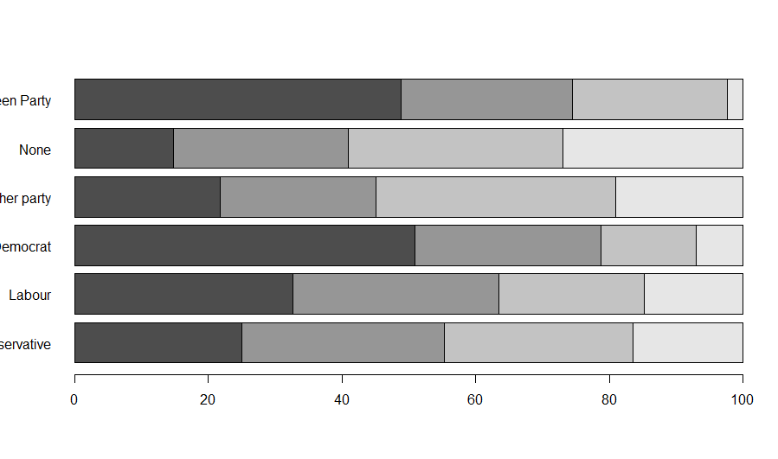

```

As above in the case of continuous variables, barplot()provides a tool for the rapid visualisation of contingency tables. However, users who need more advanced graphic capabilities will use ggplot()and will refer to the package documentation for more information.

## 8. Plotting simple maps in R

The BSA dataset does not contain any geographical variables, meaning this section cannot be replicated with the BSA dataset.

Could we introduce a new dataset here, maybe the Quarterly Labour Force Survey, January - March, 2016 (LFS), used in the original guide?

## 9.1 Further commands and analyses

We have reached the limits of what can be illustrated within the space of this guide. Users interested in carrying out more advanced analysis should consult the links and references listed in the next section ‘Additional resources’.

The following non exhaustive list provides a few examples of commands and packages that tackle common types of analysis which might be relevant to users of large UK surveys

• Regression analysis: the glm() command installed by default with R can be used for fitting simple and multiple linear and non linear regressions including logistic regression and more generally models falling under the Generalized Linear Model framework. In addition, the package ‘lme4’ allows to fit linear multilevel (ie mixed effects) models, whereas ‘nlme’ allows to fit non linear multilevel models. • Complex survey data and analysis commands and functions can be found in the ‘survey’ package. It includes commands for taking into account stratified and clustered samples, weights compute design effects and confidence intervals, etc.. • Users interested in latent variable modelling will be interested in the factanal() command. Other resources are provided in the ‘poLCA’ (Latent Class Analysis), ‘ltm’ (Latent Trait modelling), ‘sem’ (Structural equation modelling) packages • Users interested in longitudinal and time series analysis will be interested in the ‘stats’ and the, ‘tseries’ packages. The packages ‘survival’ and ‘eha’ deal with event history and survival analysis, whereas ‘grofit’ and ‘plm’ are designed for panel data and growth analyses.

## 10. Additional online resources

There are hundreds of web sites dedicated to R that users can consult, in addition to CRAN and the main R help list, R-Help with its searchable archives. A few of the most common ones are listed here: • www.ats.ucla.edu/stat/r/ - as with other statistical packages, the UCLA website provides a good starting point for the beginner • www.unt.edu/rss/class/Jon/R_SC/ at the University of North Texas provides useful links to R resources • www.r-bloggers.com/ contains many posts about R - in particular, www.r-bloggers.com/r-tutorial-series-r-beginners-guide-and-r-bloggers-updates/ contains useful introductory information • stats.stackexchange.com/ is not specific to R but contains forum-type questions and answers raised by R users • www.harding.edu/fmccown/r/ presents useful information about graphs in R. • www.bristol.ac.uk/cmm/learning/course.html - the Centre for Multilevel modeling at Bristol University has several pages dedicated to R users interested in Multilevel modeling

## 

## 11. References

R Core Team. (2017). R: A language and environment for statistical computing. Vienna, Austria: R Foundation for Statistical Computing. Retrieved from <https://www.r-project.org/> RStudio Team. (2016). RStudio: Integrated Development for R. Boston, USA: RStudio, Inc. Retrieved from <http://www.rstudio.com/> Tennekes, M. (2017). tmap: Thematic Maps. R package version 1.10. Retrieved from <https://cran.r-project.org/package=tmap> Wickham, H., & Francois, R. (2016). dplyr: A Grammar of Data Manipulation. R package version 0.5.0. Retrieved from <https://cran.r-project.org/package=dplyr> Wickham, H. ggplot2: Elegant Graphics for Data Analysis. Springer-Verlag New York, 2009. Retrieved from <https://cran.r-project.org/package=ggplot2>

* pipes
* comments